RFP Architecture Questionnaire
Please fill in your project’s details. For reference and examples from other projects, please refer to the following documents - they have different forms, but mostly the same information bits:
פרוייקט "טופס 17" ו פרוייקט "אשפוזי בית".

Also, see Appendix A for general guidance on implementation approaches.

Basics
What are the business entities involved, how many?
Examples:
- 1 HMO, 1-5 hospitals
- Dozens of labs, potentially hundreds of client apps
- 10-15 research facilities
Existing infrastructure storing/managing clinical data, if applicable.
Examples: Epic EMR, Chameleon, Legacy mainframe
Existing integration platforms, if applicable.
Examples: Intersystems, Tibco
FHIR architectural approach (FHIR server, Façade, Asynchronous messaging, Hybrid):
Are the components all on-prem, in cloud, hybrid? If in cloud, which one(s)?
What infrastructure/platform will be used for FHIR server/façade/messaging? Provide vendor/system names and is it already present in your organization or will be acquired/installed for the project?
Is the FHIR interface read-only (only exposing existing clinical data in FHIR) or read/write (enables adding new clinical data and/or modifying existing one)?

Diagrams

- Overall Architecture diagram/s.
  - Should include main components such as source, target and intermediary systems of data/command exchange, application and storage components, security components.
  - Should indicate cloud/on-prem separation, if applicable.
  - Should indicate vendors and platform names.
  - Should indicate protocols/data formats where applicable.
  - You’re welcome to add any verbal explanation for better understanding.
(See example in Appendix B)

- Data flow diagrams for common use cases / API. Please attach a number beside each call in the sequence and add verbal explanation for each step
Example:
(See example in Appendix B)

Data handling and sync
Is the data exposed in FHIR originating from/should be copied to other organizational systems?

If the data must be synchronized with other organizational systems - what is the acceptable synchronization delay?

If FHIR façade/Server will be used - where and how data will be stored?

Will space optimization (e.g. compression, BSON) be used?

Sizing and scale
Please provide figures you know or estimates, if exact numbers are not known at this stage.

What is the total dataset size that you will be exposing via FHIR (overall size of the entire clinical data available through FHIR, in MB/GB)?

What's the average number of calls per day expected to the planned FHIR endpoint(s)?

If usage peaks are expected, please describe peak length and number of calls.

Examples:
- most of the working day around 100 requests an hour, but from 8am to 9am expected peak of 5k requests.
- almost none during the week, but around 300 throughout the weekend.

What is the average size of a single data payload transferred via the planned FHIR endpoint(s)?

Will the FHIR interface be exposed to multiple consumers? If yes, how many?

Examples:
- To all labs, potentially hundreds
- From the app side to the 4 HMOs, from the HMO side - only to the app
- Now only to one, maybe more in the future.

What is the expected number of concurrent requests (normally and during peak)?

Where applicable - how scalability/availability/redundancy will be addressed?

FHIR infrastructure and behavior
Does the infrastructure/platform that will be used for FHIR natively support FHIR in client and/or server modes (i.e. FHIR client and/or FHIR server/facade is built into the platform) or it will require additional extensions/modules/custom development? If custom development is required, indicate runtime platform/programming language.

Is there a need for custom behavior on top of the supported FHIR specifications, which will require any customization or development (please detail which ones)? If custom development is required, indicate runtime platform/programming language.

Will FHIR profiles conformance validation (except for codesystems) be performed and if yes - how it'll be done (online/ batch, what tools/infrastructure will be used)?

Will codesystems validation be performed and if yes - how it'll be done (online/ batch, what tools/infrastructure will be used)?

Security
Network security measures (VPN, static IPs, TLS & certificates, etc.)?

FHIR endpoint security: what approach will be used (OAuth2, SMART on FHIR, other?)

Authorization/access control: do users have limited access rights and if yes - how those are implemented (SMART on FHIR scopes, launch context provided by EMR, other?)

Are any FHIR resources planned to have attachments in them? If yes - are any security precautions planned about them?

Are FHIR security labels used? If yes - how?

Audit: does the solution provide means to get audit trail of access to FHIR data and/or specific operations on it. If yes - how?

Miscellaneous

How will the FHIR interface be monitored for quality & availability?

Will specialized security platforms/gateways be used for online/asynchronous schema validation? If yes, do they natively support FHIR?

Any other additional details worth mentioning:
_______________________________________________________________________________

Appendix A: Implementation approaches
 | FHIR server | FHIR Façade | Messaging
Legend:  - Green: well suited  - Orange: partially suited  - Red - Ill suited | online request/response style communication with the data persisted in the FHIR server itself and replicated in/out to other systems as necessary | online request/response style communication without persisting the data, but rather dynamically translating online requests to/from FHIR and forwarding them to other systems | asynchronous/batch communication, exchanging FHIR payload via message bus/queue/file shares/כספות
Large dataset used by / originated in other organizational systems that do not support FHIR
Small dataset / dataset dedicated for specific task and not used by other systems
Business needs call for online interaction
Data must be in sync with other systems in near-real time
System must support high number of concurrent requests
Time to market & solution complexity
Business needs require advanced functionality on the server side (e.g. search)
Large volumes of data must be transferred

Implementation approaches diagrams

Approach #1 - using FHIR server
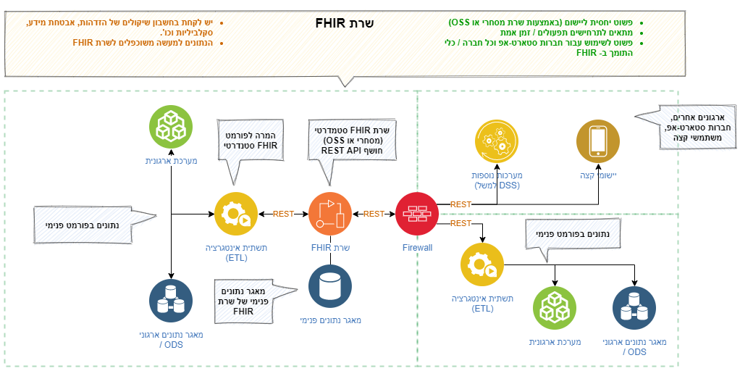

Approach #2: Using a FHIR Façade
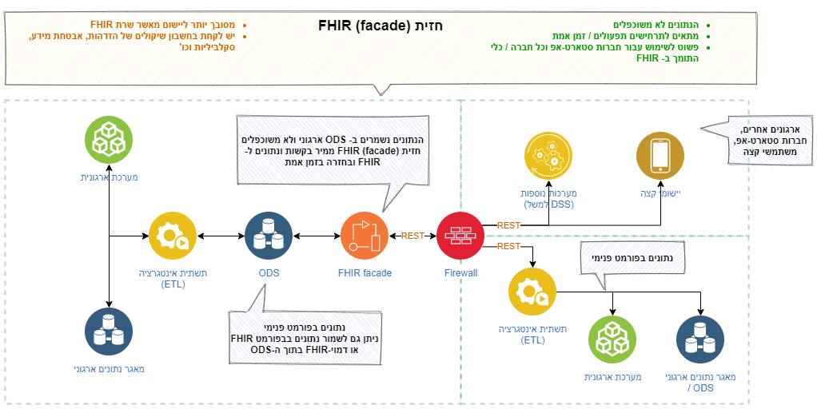

Approach # 3: Using Asynchronous messaging
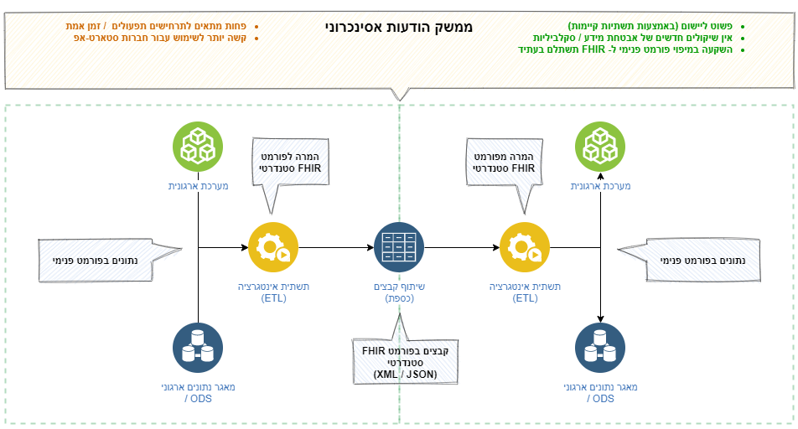

Appendix B: Sample diagrams

Architectural diagram:
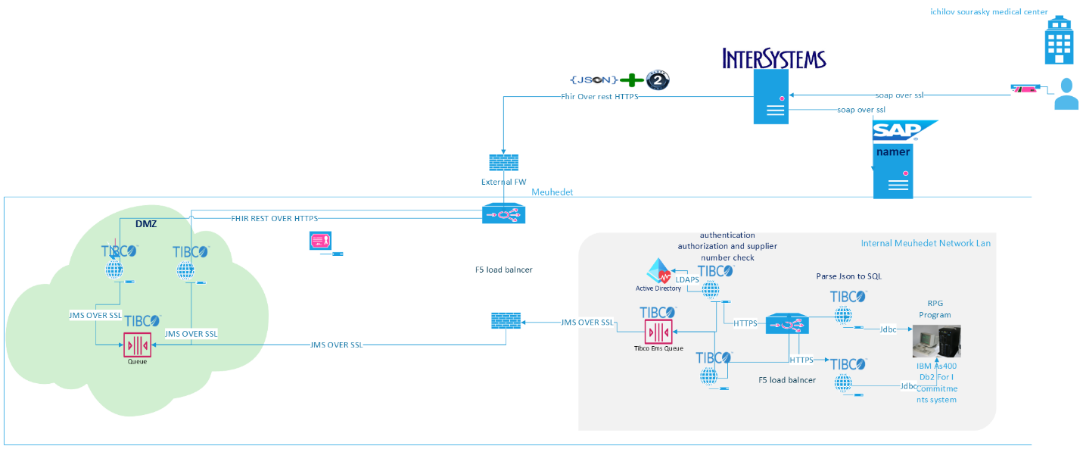

All the components are on-prem.

Data flow diagram:
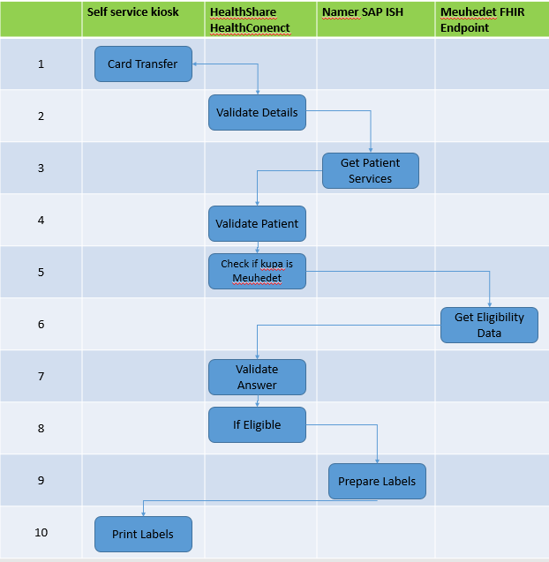

- Patient swipes his card in the kiosk
- Ichilov HealthConnect system gets the call, validates card details, calls Namer
- Namer gets patient data/services
- HealthConnect validates data, checks the required procedure Eligibility
- HealthConnect checks if HMO is Meuhedet, if yes - calls Meuhedet FHIR endpoint
- Meuhedet FHIR gets patient data, returns eligibility (Tofes 17) if it is in place (in HMO)
- HeakthConnect gets the eligibility response, validates & registers it,
- If everything is ok, calls Namer
- Namer prepares the labels for the procedure
- Kiosk prints the labels

