RFP Architecture Questionnaire

Solution Architecture Questions
- What is your architectural approach (FHIR server, Façade, Asynchronous messaging, Hybrid)?
Consult implementation approaches helper and diagrams below to help you decide.
  - Provide architecture diagrams including source, target and intermediary systems, application and storage components, security components. Indicate cloud/on-prem separation, if applicable. Indicate vendors and platform names. If custom development is required, indicate runtime platform/programming language.
  - Provide data flow diagrams for common scenarios.(attach a number beside each call in the sequence)
Meuhedet have more than 300 approved API`s, for all health care business areas, exposed to internal and public networks. The API`s designed on SOA architecture exposed by TIBCO BW Active matrix engine, on soap over http and JMS and include more that 90% of Meuhedet business process and our digital functions - like schedule appointments, create petition for physician, request for claim from digital …
We decided to wrap our soap services with FHIR based interfaces, with our on premise TIBCO BW 6.x platform HL7 FHIR Plugin.
The source system for the data and the business logic is our legacy AS400 IBM system, based on our Commitments system.
That architectural approach fits FHIR Façade infrastructure.
The solution is cordless, rapidly developed, no unnecessary data duplication and relies on Meuhedet ESB infrastructure.
The outcome is a Tibco project that can run and customize on any Tibco BW 6.x platform, and standard swagger file for implement in any platform.

Protocol work flow
הארכיטקטורה סינכרונית - http rest web services שמחזירים תשובה במידית באותו http session לבקשה עד הקצה של הקיוסק בבית החולים.

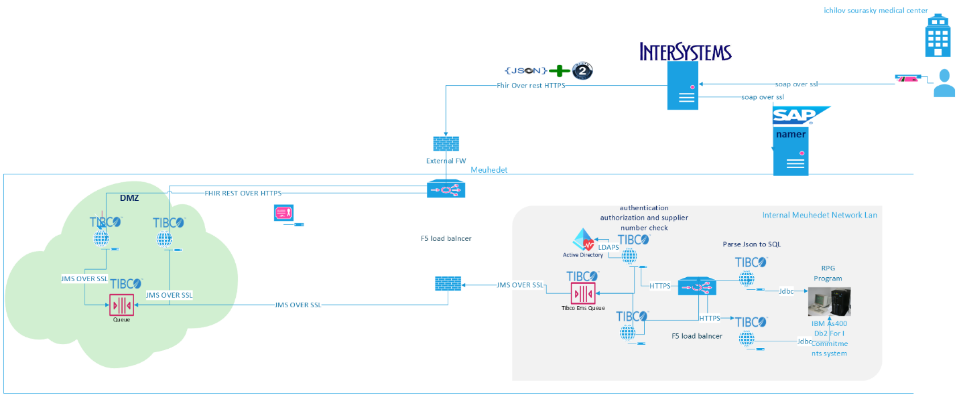
Coverage
CoverageEligibilityResponse
CoverageEligibilityRequest
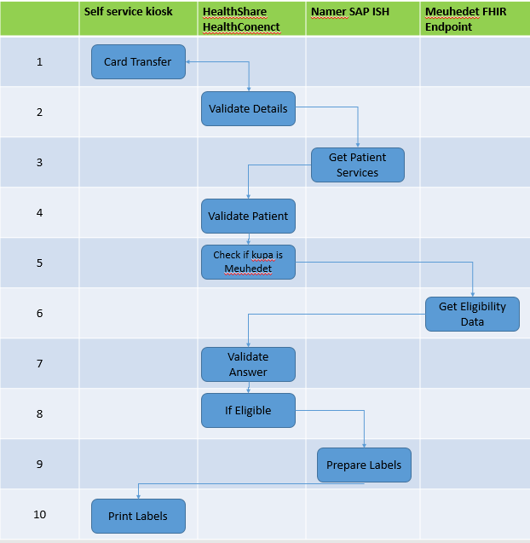

- What is the total dataset size that you will be exposing via FHIR? Is this data originating from/should be copied to other organizational systems?
The average data size is 10kb and data should not be copied or duplicated, except of logs that documented for the monitoring system. The answers returned are intended only to continue the process but are not saved in any database apart for tracing and monitoring purposes.

- If the data must be synchronized with other organizational systems - what is the acceptable synchronization delay?
The data should be real-time from our commitments system.
- What is the size of a single record (in a business sense - might include several FHIR resources) that will be transferred? What's the number of records to be transferred per day/during peak load?
The load for Ichlov medical center, can be more than 380 request per day and each call can includes 10 records.
- Will the FHIR interface be exposed to multiple consumers? What is the expected number of consumers? What is the expected amount of concurrent requests during peak load?
The potential can by all Meuhedet external suppliers, more than 500. That is potential of 500K request per day: the future estimation for 3 years from now, for all types of requests and for all meuhedet suppliers. We have 1800 suppliers and our forecast is 1000 a day for all kind of request, for 500 suppliers.

- What infrastructure/platform will be used for FHIR server/façade/messaging? Provide vendor and system names. Is it already present in your organization or will be acquired/installed for the project? Does it natively support FHIR in client and/or server modes (i.e. FHIR client and/or FHIR server/facade is built into the platform) or it will require additional extensions/modules/custom development?
Meuhedet -
The client we will use to implement Fhir is Tibco HL7 Fhir Plugin, is Fhir Certificate Client for Fhir and natively support and restrict Fhir standard. Need to be install and licensed. For this eligibility check MEUHEDET is only the server side, its relevant only for future interfaces.
We discussed and agree on extension for the error object on the coverage eligibility response.
The reason is the resource coverage request, get area of treatments codes and the response returns commitments for the treatments codes.
There are treatments codes that don’t have commitments for several reasons – the treatments codes don’t exists, treatments codes not approved…
That reason we should have 2 more string fields on the error element - treatments codes and error description.
Soraski’s The product is HealthShare Health Connect version 2021.1 Vendor: Intersystems.
The product is already installed in the organization as a dedicated integration server.
The product natively supports FHIR in both client and server modes.

- Where applicable - how scalability/availability/redundancy will be addressed?
Meuhedet have a full redundancy, based on F5 and ESB infrastructure, that’s running on duplicate systems on 2 different sites. The infrastructure monitored 24/7 with Meuhedet monitoring systems. Tibco Active Matrix infrastructure have built in scale up tolls and utilities, for on premise virtual servers.
Soraski data is kept for a period of time in HealthShare Health Connect for monitoring purposes only and deleted periodically.

- If FHIR façade/Server will be used - where and how data will be stored?
No data will duplicate, all data stay on the internal source system.
- Where will the components of the solution be located (on-prem/cloud/hybrid)? If on a cloud , please describe which provider. On premise.
- How will the FHIR interface be monitored for quality & availability?
Meuhedet have CA NimSoft monitoring system and Glass Box.
- How the interface will be secured (VPN, static IPs, TLS & certificates, etc.)? Will specialized security platforms/gateways be used for online/asynchronous schema validation? If yes, do they natively support FHIR?
Meuhedet use rout base on static ip Over SSL, F5 rout and Load balance, API getaway for Authentication and Authorization, based on JWT token, transfer on the Bearer Header. The validation base on Tibco Fhir plugin, on the Tibco ESB layer.
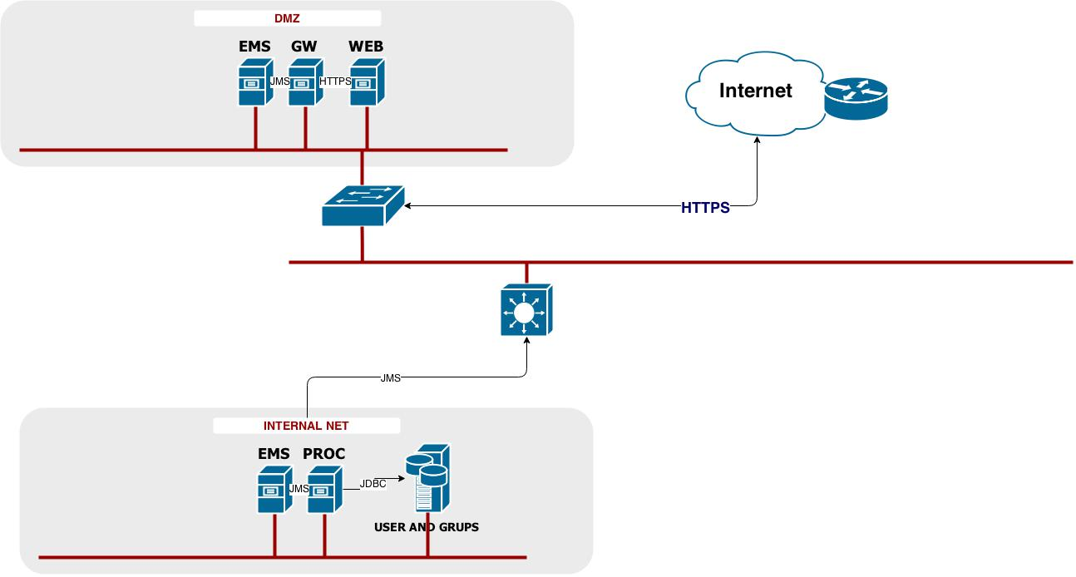

- For message based asynchronous communication - how data will be packaged (e.g. resources as individual files, FHIR bundle, custom envelope format - e.g. JSON array, bulk FHIR, etc.). Will space optimization (e.g. compression, BSON) be used? Is the selected infrastructure/platform compatible with the chosen format out of the box or additional customizations will be required?
On Meuhedet side - Massaging mechanism based on Tibco EMS massaging Queueing system over JMS. The Massages are JSON packed in bundle of Coverage Eligibility Request resource with the out of the box structure.
On Soraski side - The resources are sent as part of a FHIR Bundle – HealthShare Health Connect natively supports it.

- Will FHIR resources conformance validation be performed and if yes - how it'll be done (online/ batch, what tools/infrastructure will be used)?
Validation by swagger structure and XSD schema.
- Will codesystems validation be performed and if yes - how it'll be done (online/ batch, what tools/infrastructure will be used)?
On Meuhedet side - Code validation performed with Tibco Active matrix base tools.
Soraski side - ode Systems are validated as part of their acceptance as part of the resource in HealthShare Health Connect - online checking.

Implementation approaches
 | FHIR server | FHIR Façade | Messaging
Legend:  - Green: well suited  - Orange: partially suited  - Red - Ill suited | online request/response style communication with the data persisted in the FHIR server itself and replicated in/out to other systems as necessary | online request/response style communication without persisting the data, but rather dynamically translating online requests to/from FHIR and forwarding them to other systems | asynchronous/batch communication, exchanging FHIR payload via message bus/queue/file shares/כספות
Large dataset used by / originated in other organizational systems that do not support FHIR
Small dataset / dataset dedicated for specific task and not used by other systems
Business needs call for online interaction
Data must be in sync with other systems in near-real time
System must support high number of concurrent requests
Time to market & solution complexity
Business needs require advanced functionality on the server side (e.g. search)
Large volumes of data must be transferred

Implementation approaches diagrams

Approach #1 - using FHIR server
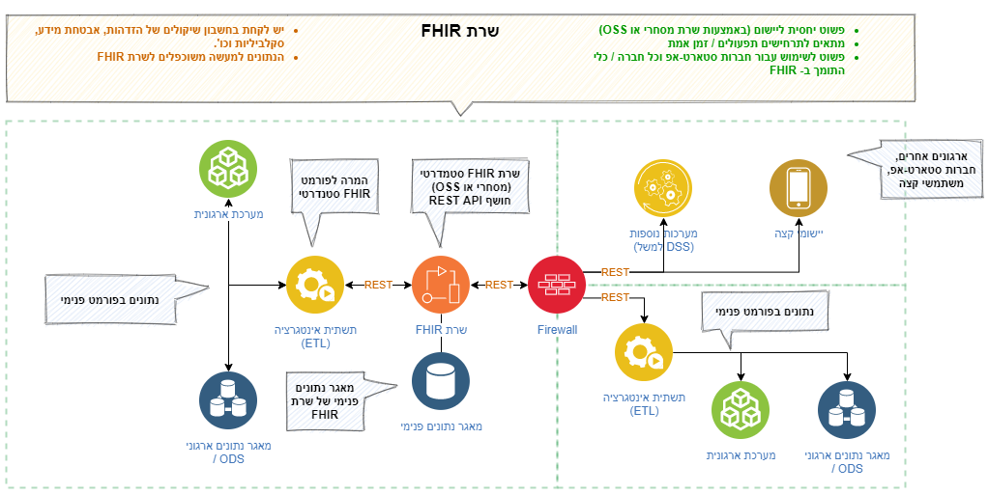

Approach #2: Using a FHIR Façade
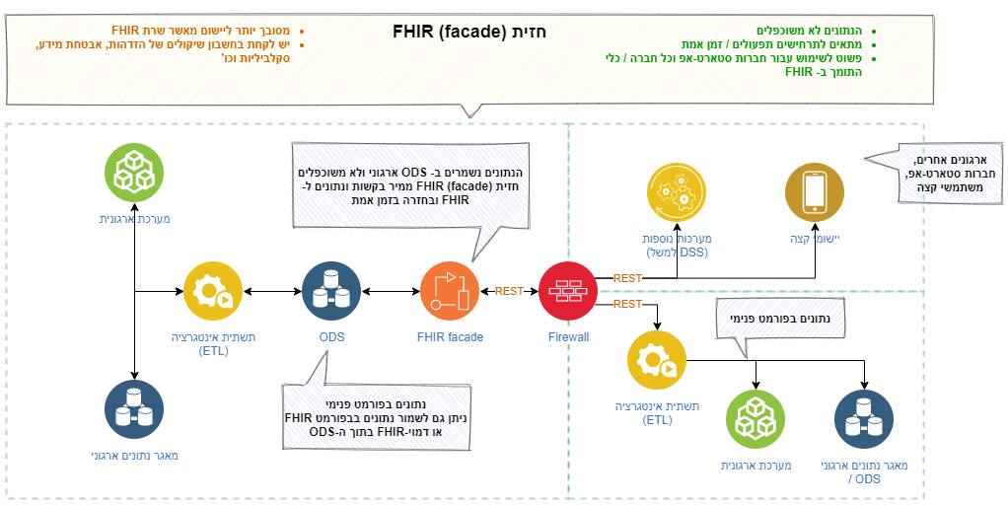

Approach # 3: Using Asynchronous messaging
